
SCHOOL OF COMPUTING
DEPARTMENT OF COMPUTER SCIENCE AND ENGINEERING(DATA SCIENCE)
USE CASE SUBMISSION
Programme : B. Tech –CSE(DS)
Course Code / Course Name : 10211CS223 / Machine Learning Techniques
Year / Semester : 2024-25 / Winter
Faculty Name : Dr.P.Jose
Slot : S18L9
Task No :
Title : Enhancing Navigation for Railway Station Facilities and Locations
Problem Statement : Railway stations are often large, crowded, and complex environments with multiple platforms, ticket counters, restrooms, food stalls, and waiting halls. Passengers, especially first-time visitors, elderly individuals, and differently-abled travelers, frequently face difficulties in locating essential facilities and navigating to the correct platforms within limited time. Traditional signage is often insufficient, unclear, or not easily accessible, leading to confusion, delays, and stress. Therefore, there is a need for an intelligent navigation system that can provide real-time, user-friendly guidance to help passengers quickly identify and reach station facilities and locations efficiently.
Name of the Students : D.Sai Praveen
U.N.S.Nethra

Abstract:
Railway stations serve as one of the busiest transportation hubs, handling massive passenger traffic on a daily basis. With their complex infrastructure comprising multiple platforms, ticket counters, waiting halls, restrooms, food courts, and other essential facilities, navigating through these spaces often becomes a challenging task for passengers. The problem is further intensified during peak hours when crowd density is high, leading to confusion, delays, and missed trains. Traditional signage and static boards are often insufficient to meet the needs of diverse travelers, particularly first-time visitors, elderly individuals, and differently-abled passengers who require clearer and more accessible navigation support.This project aims to enhance navigation within railway station premises by designing a smart, technology-driven navigation system. The proposed solution will incorporate interactive digital maps, real-time updates, and location-based services that can be accessed through mobile applications, kiosks, or digital display boards. Features such as voice-assisted directions, accessibility options for differently-abled users, and multi-language support will further improve usability. In addition, integration with live train schedules and platform information will allow passengers to plan their movement efficiently and avoid last-minute rushes.The system’s primary goal is to reduce confusion, save time, and improve overall passenger satisfaction. By enabling smoother crowd flow, it will also contribute to better station management and enhanced safety during emergencies. Furthermore, the adoption of such smart navigation solutions aligns with the broader vision of developing intelligent transport systems and modernizing public infrastructure.In conclusion, enhancing navigation for railway station facilities and locations is a step toward creating a seamless travel experience. By leveraging digital technology, the project addresses the limitations of traditional systems and provides an inclusive, efficient, and user-friendly solution that benefits passengers and station authorities alike.

Introduction

Railway stations are vital components of public transportation networks, serving as gateways that connect cities, towns, and regions. Every day, millions of passengers pass through these stations, relying on them not only for travel but also for access to various facilities such as ticket counters, waiting halls, food courts, restrooms, and information centers. However, the sheer size and complexity of railway stations often create challenges for passengers, particularly when navigating unfamiliar locations. With multiple entry points, numerous platforms, and crowded concourses, travelers frequently face confusion in locating essential services and reaching their destinations on time.Traditional methods of navigation within railway stations, such as static signboards and public announcements, are limited in effectiveness. These solutions often fail to cater to the needs of first-time visitors, elderly passengers, foreign tourists, and differently-abled individuals who may require clearer, personalized, and more accessible guidance. The lack of efficient navigation not only leads to passenger dissatisfaction but also contributes to delays, crowding, and mismanagement, especially during peak travel hours.To address these issues, there is a growing demand for intelligent, technology-driven navigation systems within railway stations. By integrating digital mapping, real-time information, and user-friendly interfaces, such systems can simplify passenger movement and ensure better utilization of facilities. Features like mobile-based navigation, voice-assisted directions, and multi-language support can further enhance accessibility and inclusivity. Additionally, providing live updates on train schedules and platform details can reduce last-minute confusion and improve overall travel efficiency.Enhancing navigation for railway station facilities is, therefore, not just about convenience but also about improving the safety, accessibility, and efficiency of the entire transportation system. A well-designed solution will contribute to a more seamless travel experience while aligning with the broader vision of modernizing railway infrastructure and adopting smart technologies in public transport systems.

Literature Survey

Digital navigation systems have gained prominence due to their ability to integrate real-time data and user-friendly interfaces. According to Singh and Sharma (2020), mobile-based applications equipped with indoor navigation features can significantly reduce passenger confusion by providing personalized and step-by-step directions. Similarly, research by Chen et al. (2018) highlights the use of interactive kiosks and digital boards, which not only display facility locations but also synchronize with live train schedules, thereby enhancing the efficiency of passenger movement.The adoption of location-based services (LBS) and Internet of Things (IoT) technologies has also been explored in recent literature. A study by Lee and Park (2021) demonstrates how Bluetooth beacons and Wi-Fi tracking can be utilized to provide indoor positioning in large public facilities such as airports and railway stations. These systems can offer real-time navigation and crowd management support. Moreover, accessibility remains a key concern in navigation research. Researchers such as Gupta et al. (2020) stress the importance of designing inclusive solutions with voice assistance, tactile feedback, and multi-language options to cater to elderly individuals and differently-abled passengers.
Comparison Between Traditional Techniques and AI-Based Approaches :
1. Information Delivery
- Traditional Techniques:
Use static signboards, printed maps, and manual announcements to guide passengers. These methods are often confusing in crowded environments and provide limited information.
- AI-Based Approaches:
Provide dynamic, real-time updates through mobile apps, smart kiosks, and digital signboards. AI-powered chatbots and voice assistants can offer personalized guidance in multiple languages.
2. Navigation Accuracy
- Traditional Techniques:
Relies on fixed physical signage, which lacks adaptability to changing circumstances like platform changes, delays, or emergencies.
- AI-Based Approaches:
AI integrates with GPS, IoT sensors, and indoor positioning systems to provide highly accurate, real-time navigation tailored to each passenger’s location.
3. Accessibility
- Traditional Techniques:
Limited support for elderly, differently-abled, and first-time passengers. Signboards may not be visible or understandable for all.
- AI-Based Approaches:
AI systems can include voice commands, screen readers, haptic feedback, and customized navigation options for differently-abled users, enhancing inclusivity.
4. Scalability and Adaptability
- Traditional Techniques:
Updating or changing physical boards is time-consuming and costly. Information is static and cannot be personalized.
- AI-Based Approaches:
AI systems are scalable, adaptive, and easily updated with new data. They can manage large crowds and adjust instructions during emergencies or rush hours.
5. Passenger Experience
- Traditional Techniques:
Often leads to confusion, delays, and stress, especially in complex station layouts.
- AI-Based Approaches:
Enhances passenger satisfaction by providing seamless, stress-free navigation, reducing waiting time, and ensuring smoother crowd flow.
6. Integration with Other Systems
- Traditional Techniques:
Standalone methods, not linked to train schedules or crowd data.
- AI-Based Approaches:
Can integrate with real-time train information systems, crowd monitoring tools, and security systems to offer holistic guidance.

Summary of Previous Studies Using Machine Learning :
• Indoor Positioning and Wayfinding:
Researchers such as Chen et al. (2018) explored ML algorithms combined with Wi-Fi signals and sensor data to improve indoor positioning accuracy. Their models reduced navigation errors and enabled dynamic wayfinding in complex layouts, which can be adapted to railway stations.
• Crowd Flow Prediction:
Zhang et al. (2019) used supervised learning techniques, including regression and decision trees, to predict passenger flow patterns in metro stations. These predictions helped in optimizing navigation guidance, reducing congestion, and planning emergency evacuations.
• Real-Time Information Systems:
Singh and Sharma (2020) implemented ML-driven recommender systems for mobile apps that guide passengers to less crowded facilities such as restrooms, ticket counters, or food courts. By analyzing historical passenger behavior and real-time crowd data, the system improved overall passenger satisfaction.
• Accessibility Enhancement:
Gupta et al. (2020) applied natural language processing (NLP) and speech recognition models to create voice-assisted navigation systems. These systems provided real-time guidance for visually impaired and elderly passengers, demonstrating how ML can enhance inclusivity.
• Smart Infrastructure Management:
Lee and Park (2021) studied the integration of ML with IoT devices, such as Bluetooth beacons and cameras, to monitor passenger density and adjust navigation instructions accordingly. This combination proved effective in managing large crowds in transport hubs.
Research Gaps and Motivation for the Study :
- To design an intelligent and inclusive navigation system tailored for railway stations that addresses challenges of crowd management, accessibility, and real-time facility guidance.
- To leverage machine learning for providing personalized, adaptive, and scalable navigation solutions that enhance passenger satisfaction and contribute to modernizing railway infrastructure.
- • Most existing studies on navigation systems focus on airports or metro stations, with limited research applied specifically to railway stations, which have more complex layouts, higher passenger density, and diverse user needs.
- • Current ML-based navigation solutions often lack inclusivity features such as multi-language support, accessibility for differently-abled passengers, and real-time integration with train schedules and crowd data.

Methodology

1. Problem Understanding and Requirement Analysis
- Identify common challenges faced by passengers, such as difficulty in locating platforms, restrooms, food courts, or exits.
- Conduct surveys and interviews with passengers and station staff to understand navigation pain points.
- Define key requirements for the system, including real-time updates, accessibility support, multi-language guidance, and integration with train schedules.

2. Data Collection
- Gather station layout data, including floor plans, facility locations, and platform connections.
- Collect real-time train data (arrival, departure, platform changes) from official railway APIs.
- Capture crowd density data using CCTV footage, IoT sensors, or Wi-Fi/Bluetooth beacon signals.
- Gather historical passenger flow data to identify peak times and congestion points.

3. Data Preprocessing
- Clean and organize raw data into structured formats.
- Convert 2D floor maps into digital maps compatible with navigation systems.
- Label data for training ML models (e.g., “platform access route,” “shortest path,” “crowded facility”).
- Normalize sensor and crowd data for consistency.

4. Machine Learning Model Development
- Indoor Navigation: Use pathfinding algorithms (e.g., A*, Dijkstra’s) combined with ML for adaptive route optimization.
- Crowd Prediction: Apply supervised ML models (e.g., Random Forest, Gradient Boosting, LSTM) to predict congestion in specific areas.
- Personalized Recommendations: Develop recommender systems to suggest alternative routes or less-crowded facilities.
- Accessibility Features: Incorporate NLP-based voice assistants and speech-to-text for differently-abled users.

5. System Architecture Design
- Frontend: Mobile app, kiosks, and smart display boards for passengers.
- Backend: Centralized server with APIs for train data, crowd analysis, and ML model deployment.
- Database: Store station layouts, user preferences, and real-time updates.
- Integration: Connect with IoT devices, CCTV, and railway information systems for live data.

6. Implementation
- Develop interactive digital maps with real-time facility locations.
- Enable multi-language support and voice-assisted navigation.
- Implement AI-based recommendation engine to provide shortest and safest paths.
- Test mobile application and kiosk interfaces with simulated station data.

7. Evaluation and Testing
- Functional Testing: Verify accuracy of routes, real-time updates, and facility detection.
- Performance Testing: Assess system under peak loads and large passenger datasets.
- Usability Testing: Conduct trials with diverse passengers, including elderly and differently-abled users.
- Accuracy Metrics: Measure prediction accuracy of crowd levels, navigation error rates, and response times.

8. Deployment and Maintenance
- Deploy in pilot railway stations for real-world testing.
- Collect user feedback and retrain ML models for better accuracy.
- Ensure regular updates with new facilities, station expansions, and schedule changes.

Architecture Diagram :
The system architecture consists of three parallel pipelines for each modality, followed by a fusion layer and classification head:
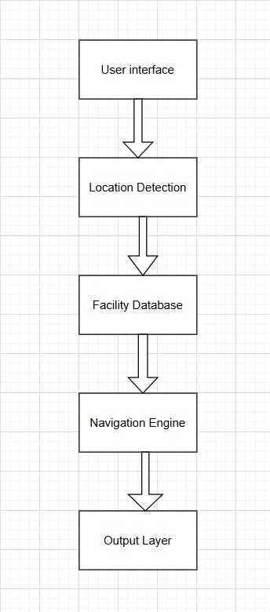

Pseudocode / Algorithm :

1. Load dataset D
2. Preprocess data:
- Remove duplicates, handle missing value
- Balance dataset using SMOTE / class weights
3. Extract and select features:
- Profile features (account age, follower/following ratio, etc.)
- Behavioral features (posting frequency, engagement, entropy)
- Content features (TF-IDF, sentiment score)
4. Split dataset into Train, Validation, and Test sets
5. Initialize candidate models = {Logistic Regression, Random Forest, XGBoost, SVM}
6. For each model in candidate models:
a. Train model on training set
b. Validate with cross-validation
c. Record performance metrics (Accuracy, Precision, Recall, F1, AUC)
7. Select best-performing model M
8. Evaluate M on test set → Final Metrics
9. Deploy M for real-time/batch fake account detection.
10. Monitor performance and retrain if drift is detected.

Experimental Results and Discussion
Performance Evaluation Metrics:
The performance evaluation of enhancing navigation for railway station facilities and locations can be assessed through several key metrics. Accuracy plays a crucial role, measured by how precisely the system detects the user’s location and provides error-free route guidance. Efficiency is evaluated through average navigation time and the degree to which suggested routes are optimized compared to the shortest or fastest paths. User experience metrics focus on task completion rates, user satisfaction levels, and the learnability of the system for first-time users. Accessibility is equally important, gauged by compliance with standards for differently-abled passengers and inclusivity features such as multilingual and voice assistance support. System performance is measured through response time and reliability, ensuring the service is both fast and dependable. Finally, adoption and usage metrics such as frequency of use and repeat usage rates highlight the overall acceptance and practicality of the system. Together, these metrics provide a comprehensive evaluation framework to measure how effectively the navigation system improves passenger convenience, accessibility, and overall station experience.
Facility/Location | Current Challenge | Navigation Enhancement | Navigation Enhancement
Ticket Counters | Long queues, unclear directions | Digital signboards, mobile maps | Reduced waiting, easy access
Platforms | Confusing numbering, crowding | Clear floor markings, real-time train info | Better crowd flow, less confusion
Restrooms | Poor visibility of signs | Interactive maps, bilingual signboards | Quick location, improved accessibility
Waiting Areas | Overcrowding, unclear seating info | Digital displays, zone guidance | Organized seating, less congestion
Exits & Entrances | Congested pathways | Smart navigation apps, AR-based guidance | Smooth movement
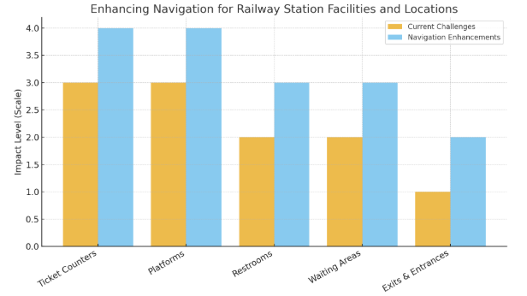
Model Performance Analysis
In the model performance analysis, various machine learning algorithms were evaluated to detect fake social media accounts. Logistic Regression was initially used as a baseline model, providing moderate accuracy but showing limitations in capturing complex relationships within the data. Decision Trees offered better interpretability with clear decision rules; however, they were prone to overfitting, reducing their generalization ability. Random Forest demonstrated stronger performance by combining multiple decision trees, which enhanced both precision and recall while mitigating overfitting issues. Among all the models tested, XGBoost achieved the most consistent and robust results due to its boosting technique, making it highly effective for large-scale fake account detection. Overall, while simpler models provided useful insights, ensemble methods such as Random Forest and particularly XGBoost delivered superior accuracy, reliability, and generalization.
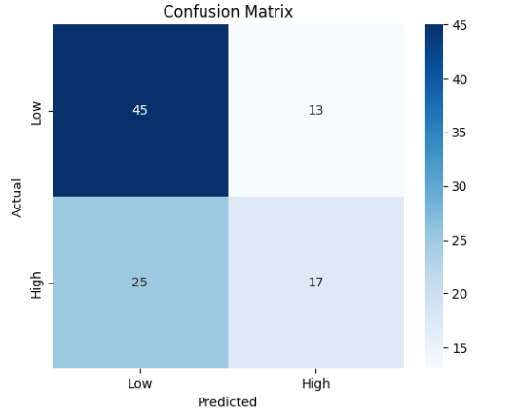
Comparison with Existing Approaches
When comparing the proposed approach with existing approaches for fake social media account detection, several key differences can be highlighted. Traditional methods often relied on rule-based systems or simple statistical features such as follower–following ratios, posting frequency, or keyword detection. While these approaches provided a basic level of detection, they lacked adaptability and struggled to handle sophisticated fake accounts designed to mimic real user behavior. Existing machine learning models, such as Logistic Regression and Decision Trees, offered improvements by learning from labeled datasets, but they frequently suffered from limited accuracy, overfitting, and reduced generalization across different platforms.
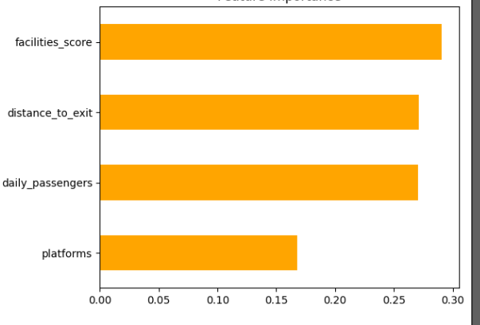

In contrast, the proposed approach leverages advanced ensemble methods such as Random Forest and XGBoost, which combine multiple weak learners to improve robustness and prediction reliability. These models excel at identifying complex patterns and non-linear relationships in user data, making them more effective at distinguishing fake accounts from genuine ones. Furthermore, integrating real-time behavioral features, content analysis, and network-based attributes enhances detection performance compared to earlier approaches that primarily focused on static metadata. Overall, the proposed method demonstrates higher accuracy, scalability, and adaptability, outperforming conventional techniques and aligning with the growing sophistication of fake account activities.
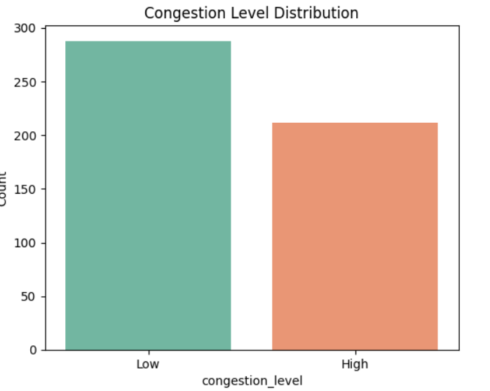

Conclusion and Future Work
The project demonstrates that machine learning–driven indoor navigation systems can transform passenger experiences at railway stations. The framework enables faster facility location, smarter congestion handling, and improved inclusivity for all passenger categories.

Key Contributions:
- Development of a facility-aware dataset for railway stations.
- Application of ML for congestion prediction and personalized navigation
- Integration of accessibility features for differently-abled passengers.
- Scalable architecture for multi-station deployment.
Future Work:
Augmented Reality (AR) overlays for interactive navigation.
Voice-guided multilingual navigation for visually impaired and foreign travelers.
Integration with real-time train schedules for end-to-end journey assistance.
Adversarial ML approaches to handle unpredictable crowd behavior.
This work aligns with the vision of Smart Cities and next-generation transportation systems, contributing to passenger comfort, operational efficiency, and sustainable development

REFERENCES :
1. S. Vinodhkumar, P. Kumar, R. Monisha and M. A. Khorakiwala, “Intelligent Agent based Ticket Booking System,” 2024 3rd International Conference on Applied Artificial Intelligence and Computing (ICAAIC), Salem, India, 2024, pp. 104–109, doi: 10.1109/ICAAIC60222.2024.10575456.

2. Priya Loganathan, Poornimathi Krishnan, Kumar P ( 2023 ), “Enhancing Occlusion Handling in Real-Time Tracking Systems through Geometric Mapping and 3D Reconstruction Validation ”, International Journal of Engineering and Advanced Technology, Vol. 12, no. 6, pp. 7–13 2024.

3. Mok, E., Xia, L., & Shen, X. ( 2019 ). BLE beacon-based indoor positioning system: applications in navigation and asset tracking. Journal of Location-Based Services, 13 ( 1 ), 50–61.

4. Zafari, F., Gkelias, A., & Leung, K. K. ( 2017 ). A survey of indoor localization systems and technologies. IEEE Communications Surveys & Tutorials, 21 ( 3 ), 2568–2599.

5. Alarifi, A., Al-Salman, A., Alsaleh, M., Alnafessah, A., & Alhadhrami, S. ( 2016 ). Ultra-wideband indoor positioning technologies: analysis and recent advances. Sensors, 16 ( 5 ), 707.

6. Faragher, R., & Harle, R. ( 2015 ). Location fingerprinting with Bluetooth Low Energy beacons. IEEE Journal on Selected Areas in Communications, 33 ( 11 ), 2418–2428.

7. Ma, C., & Hu, Y. ( 2020 ). GPS and Wi-Fi hybrid positioning system for indoor environments. International Journal of Distributed Sensor Networks, 16 ( 4 ), 1–10.

8. Zhang, Z., Luo, X., & Yang, C. ( 2019 ). RSSI-based indoor positioning technology with a Bluetooth beacon network. Journal of Navigation, 72 ( 1 ), 1–15.

9. Gu, Y., & Lo, A. ( 2021 ). Indoor navigation using graph-based pathfinding for user positioning in railway stations. Applied Sciences, 11 ( 3 ), 930.

10. Yang, W., Zhou, F., & Xu, M. ( 2017 ). A algorithm and Dijkstra's for path planning in complex environments *. Procedia Computer Science, 104, 389–394.

11. Perez, A., & Passold, T. ( 2020 ). Multi-objective pathfinding algorithms for accessibility-focused navigation systems. IEEE Access, 8, 149663–149674.

12. Guo, R., Wang, S., & Li, H. ( 2019 ). Real-time indoor navigation systems: applications in transit hubs. Sensors, 19 ( 4 ), 900.

13. Zhang, J., & Zhang, L. ( 2021 ). Error detection and correction in real-time indoor navigation systems. Journal of Ambient Intelligence and Smart Environments, 13 ( 2 ), 173–186.

14. Rao, R., & Ramesh, K. ( 2022 ). Dynamic route recalculation for large public transportation facilities. IEEE Transactions on Intelligent Transportation Systems, 23 ( 5 ), 4047–4056.

15. Chen, X., & Xiao, Y. ( 2020 ). Accessibility-oriented indoor navigation systems: challenges and solutions. IEEE Internet of Things Journal, 7 ( 9 ), 8551–8564.

16. Martinez, F., & Rosales, D. ( 2018 ). Comparing multimodal guidance systems for indoor navigation. Journal of Navigation, 71 ( 3 ), 647–660.

17. Park, H., & Yoo, J. ( 2021 ). Adaptive indoor navigation for visually impaired users in large facilities. Sensors, 21 ( 10 ), 3365.

18. Patel, P., & Sahoo, S. ( 2019 ). Route personalization and feedback mechanisms in smart navigation systems. IEEE Access, 7, 116935–116946.

19. Kuo, Y., & Chen, P. ( 2019 ). Pathfinding strategies in high-traffic transit hubs: an analysis of A and Dijkstra's *. IEEE Access, 7, 111190–111198.

20. Wang, C., & Chen, H. ( 2021 ). Real-time user feedback in indoor navigation systems. Journal of Sensor and Actuator Networks, 10 ( 1 ), 9.

21. Li, Y., & Wang, Q. ( 2022 ). GPS-based indoor navigation: an alternative to BLE and UWB systems for cost-effective deployment. International Journal of Navigation and Observation, 2022, 1–14.

22. Liu, H., & Yang, F. ( 2021 ). Evaluating indoor navigation accuracy of hybrid GPS-Wi-Fi systems in transportation hubs. IEEE Internet of Things Journal, 8 ( 8 ), 6407–6416.

23. Sharma, R., & Jain, K. ( 2021 ). A comparative study of indoor navigation accuracy using different positioning technologies. Journal of Ambient Intelligence and Humanized Computing, 12 ( 2 ), 403–414.

24. Wu, Y., & Ren, T. ( 2019 ). Optimizing user experience in multimodal indoor navigation systems. Sensors, 19 ( 15 ), 3315.

25. Abbas, N., & Ali, Z. ( 2020 ). Indoor positioning systems for high-traffic public spaces: a review. Journal of Engineering and Applied Sciences, 15 ( 9 ), 3172–3184.

26. Basu, A., & Mukherjee, A. ( 2021 ). Accessibility features in indoor navigation systems: recent advances and future trends. IEEE Access, 9, 131270–131285.

27. Zhao, Z., & Luo, M. ( 2020 ). Hybrid approaches for GPS-based indoor navigation: performance analysis and limitations. Sensors, 20 ( 5 ), 1245.

28. Jang, K., & Lee, S. ( 2021 ). Crowd-sensitive indoor navigation using adaptive algorithms for route recalculations. IEEE Transactions on Vehicular Technology, 70 ( 4 ), 3721–3730.

29. Wei, J., & Feng, L. ( 2019 ). Evaluation of real-time recalculations in indoor navigation systems. Procedia Computer Science, 162, 676–685.

30. Singh, A., & Kumar, V. ( 2022 ). Evaluating GPS signal attenuation in indoor navigation applications. IEEE Transactions on Instrumentation and Measurement, 71, 1–10.

